3’. Mother as Queen—Track 05 -no soundtrack 05 found
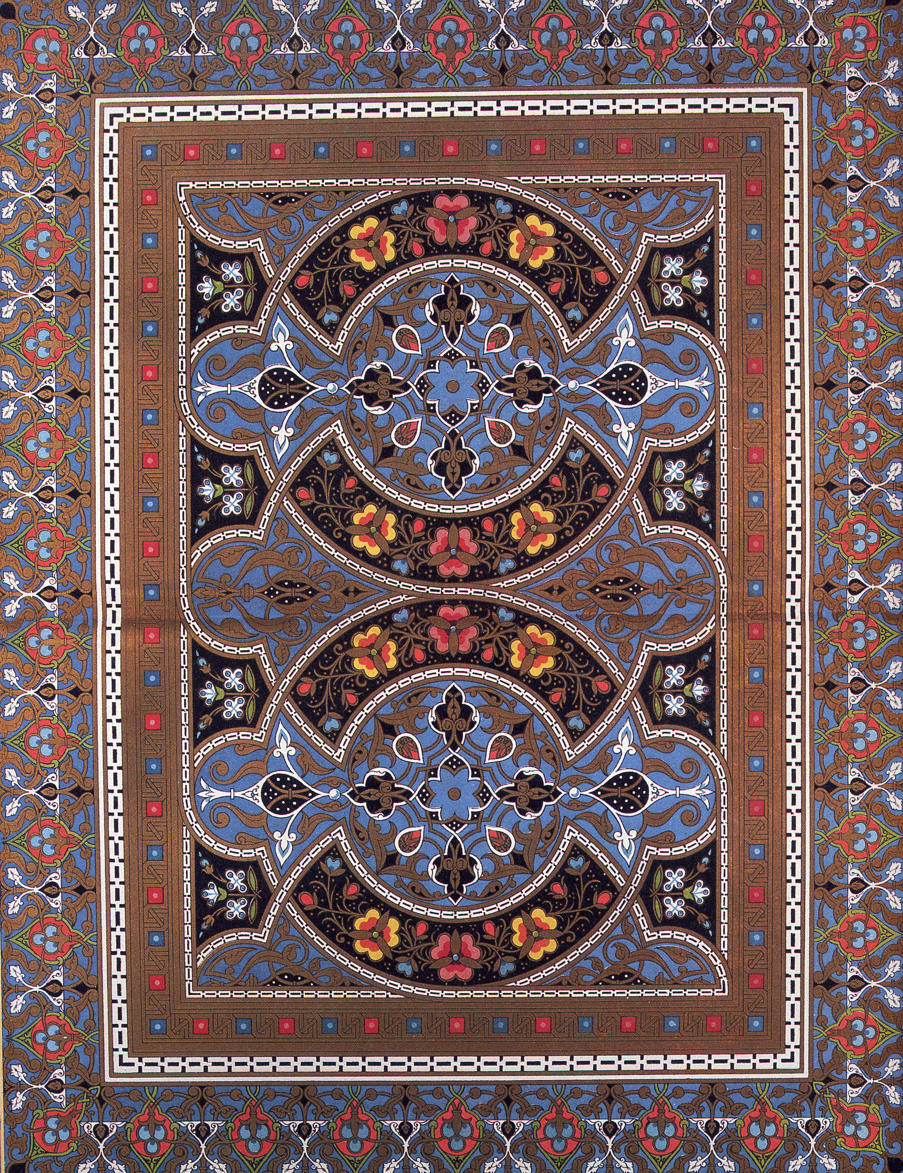
Perhaps the key to understanding the deep satisfaction that comes from the study of Islamic geometrical design is to be found in the observation that their cellular patterns resemble those networks of tracery to be found in sections of botanical or animal tissue when examined under a microscope. Unknowingly, the artists of Islam were, perhaps, after all, at a very fundamental level. ‘initiating the work of God’, and it is our unconscious recognition of this underlying unity which, in design which is at once simple yet immensely complex, gives the art of Islam its timeless beauty and universal appeal.

As your children grow, and become more capable and independent, your role changes. While you are still reliably available and warm, you find yourself flavoring your support with more coaching—the best kind of coaching. You are ready to share your experience and your belief that your child can learn and do things and be happy. And you expect her to do more of the work herself. She has to remember to take her lunch to school and keep track of homework assignments and ask her friend to her birthday party. You are there teaching her how to accomplish these tasks, standing by to offer encouragement and advice if she asks for it.

